About the CAREC Institute
CAREC Institute (CI) is an intergovernmental organization contributing to the Central Asia Regional Economic Cooperation (CAREC) Program through knowledge generation and capacity building. The Fifth Ministerial Conference on CAREC held in 2006 endorsed the establishment of CI. CI became operational in 2009 and functioned as a virtual institute until 2015. The physical base of CI was inaugurated in March 2015 in Urumqi, Xinjiang Uyghur Autonomous Region, People’s Republic of China.
The mission of CI is:
“To enhance the quality and effectiveness of the CAREC Program by providing evidence-based research, capacity building services and networking with research institutions.”
The vision of CI is:
“To be the leading Knowledge Center promoting economic cooperation in the CAREC region for shared and sustainable development.”
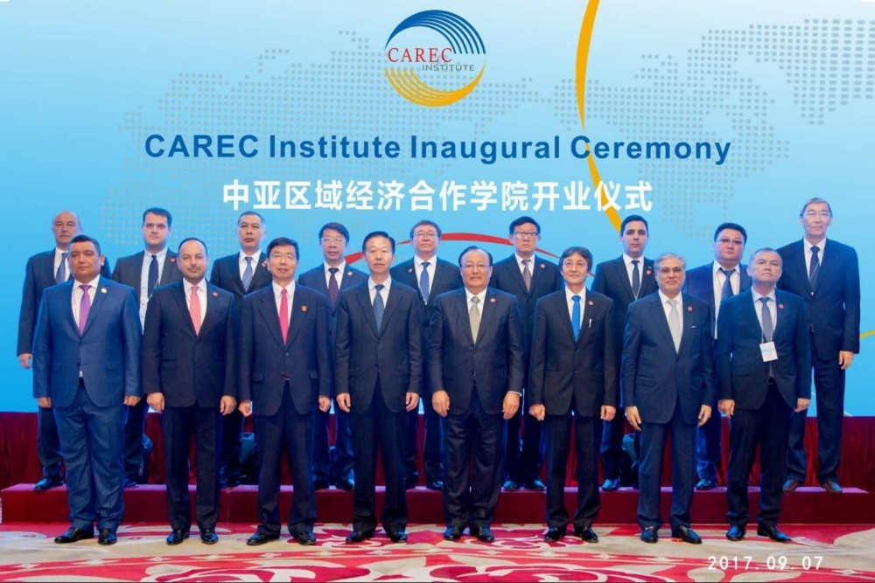
CI has the following functions:
- conduct strategic research by mobilizing and partnering with world-class intellectual resources to enhance regional cooperation capacity and accelerated growth in the CAREC region;
- promote the effectiveness of scientific research in CAREC and among the CI Member Countries through joint or collaborative projects and wide dissemination of research findings and results;
- develop a network of research institutions in the CAREC region to serve as a resource base for strategic research and knowledge sharing, comprising among others, of universities, think tanks, and development institutions;
- enhance the capabilities of government officials in CAREC and the CI Member Countries to engage in regional cooperation processes, improve their capacities to plan and implement regional cooperation projects, and build their capacities for informed policy analysis;
- provide innovative solutions based on the sharing of good practices to enable CAREC and the CI Member Countries to respond to regional challenges and cooperative processes;
- align its programs with the strategic goals of CAREC; and
- report on its past and proposed programs to CAREC at each annual meeting of the CAREC Ministerial Conference.
CI’s Strategic Knowledge Framework consists of three components:
- Knowledge generation (research activities);
- Knowledge services (capacity building activities); and
- Knowledge management (dissemination of knowledge).
The Intergovernmental Agreement (IGA) establishing the CAREC Institute was signed on 26th October 2016 and entered into force on 24th August 2017. The effectiveness of the IGA was celebrated during the CAREC Institute Inaugural Ceremony held on 7 September 2017 in Urumqi.

